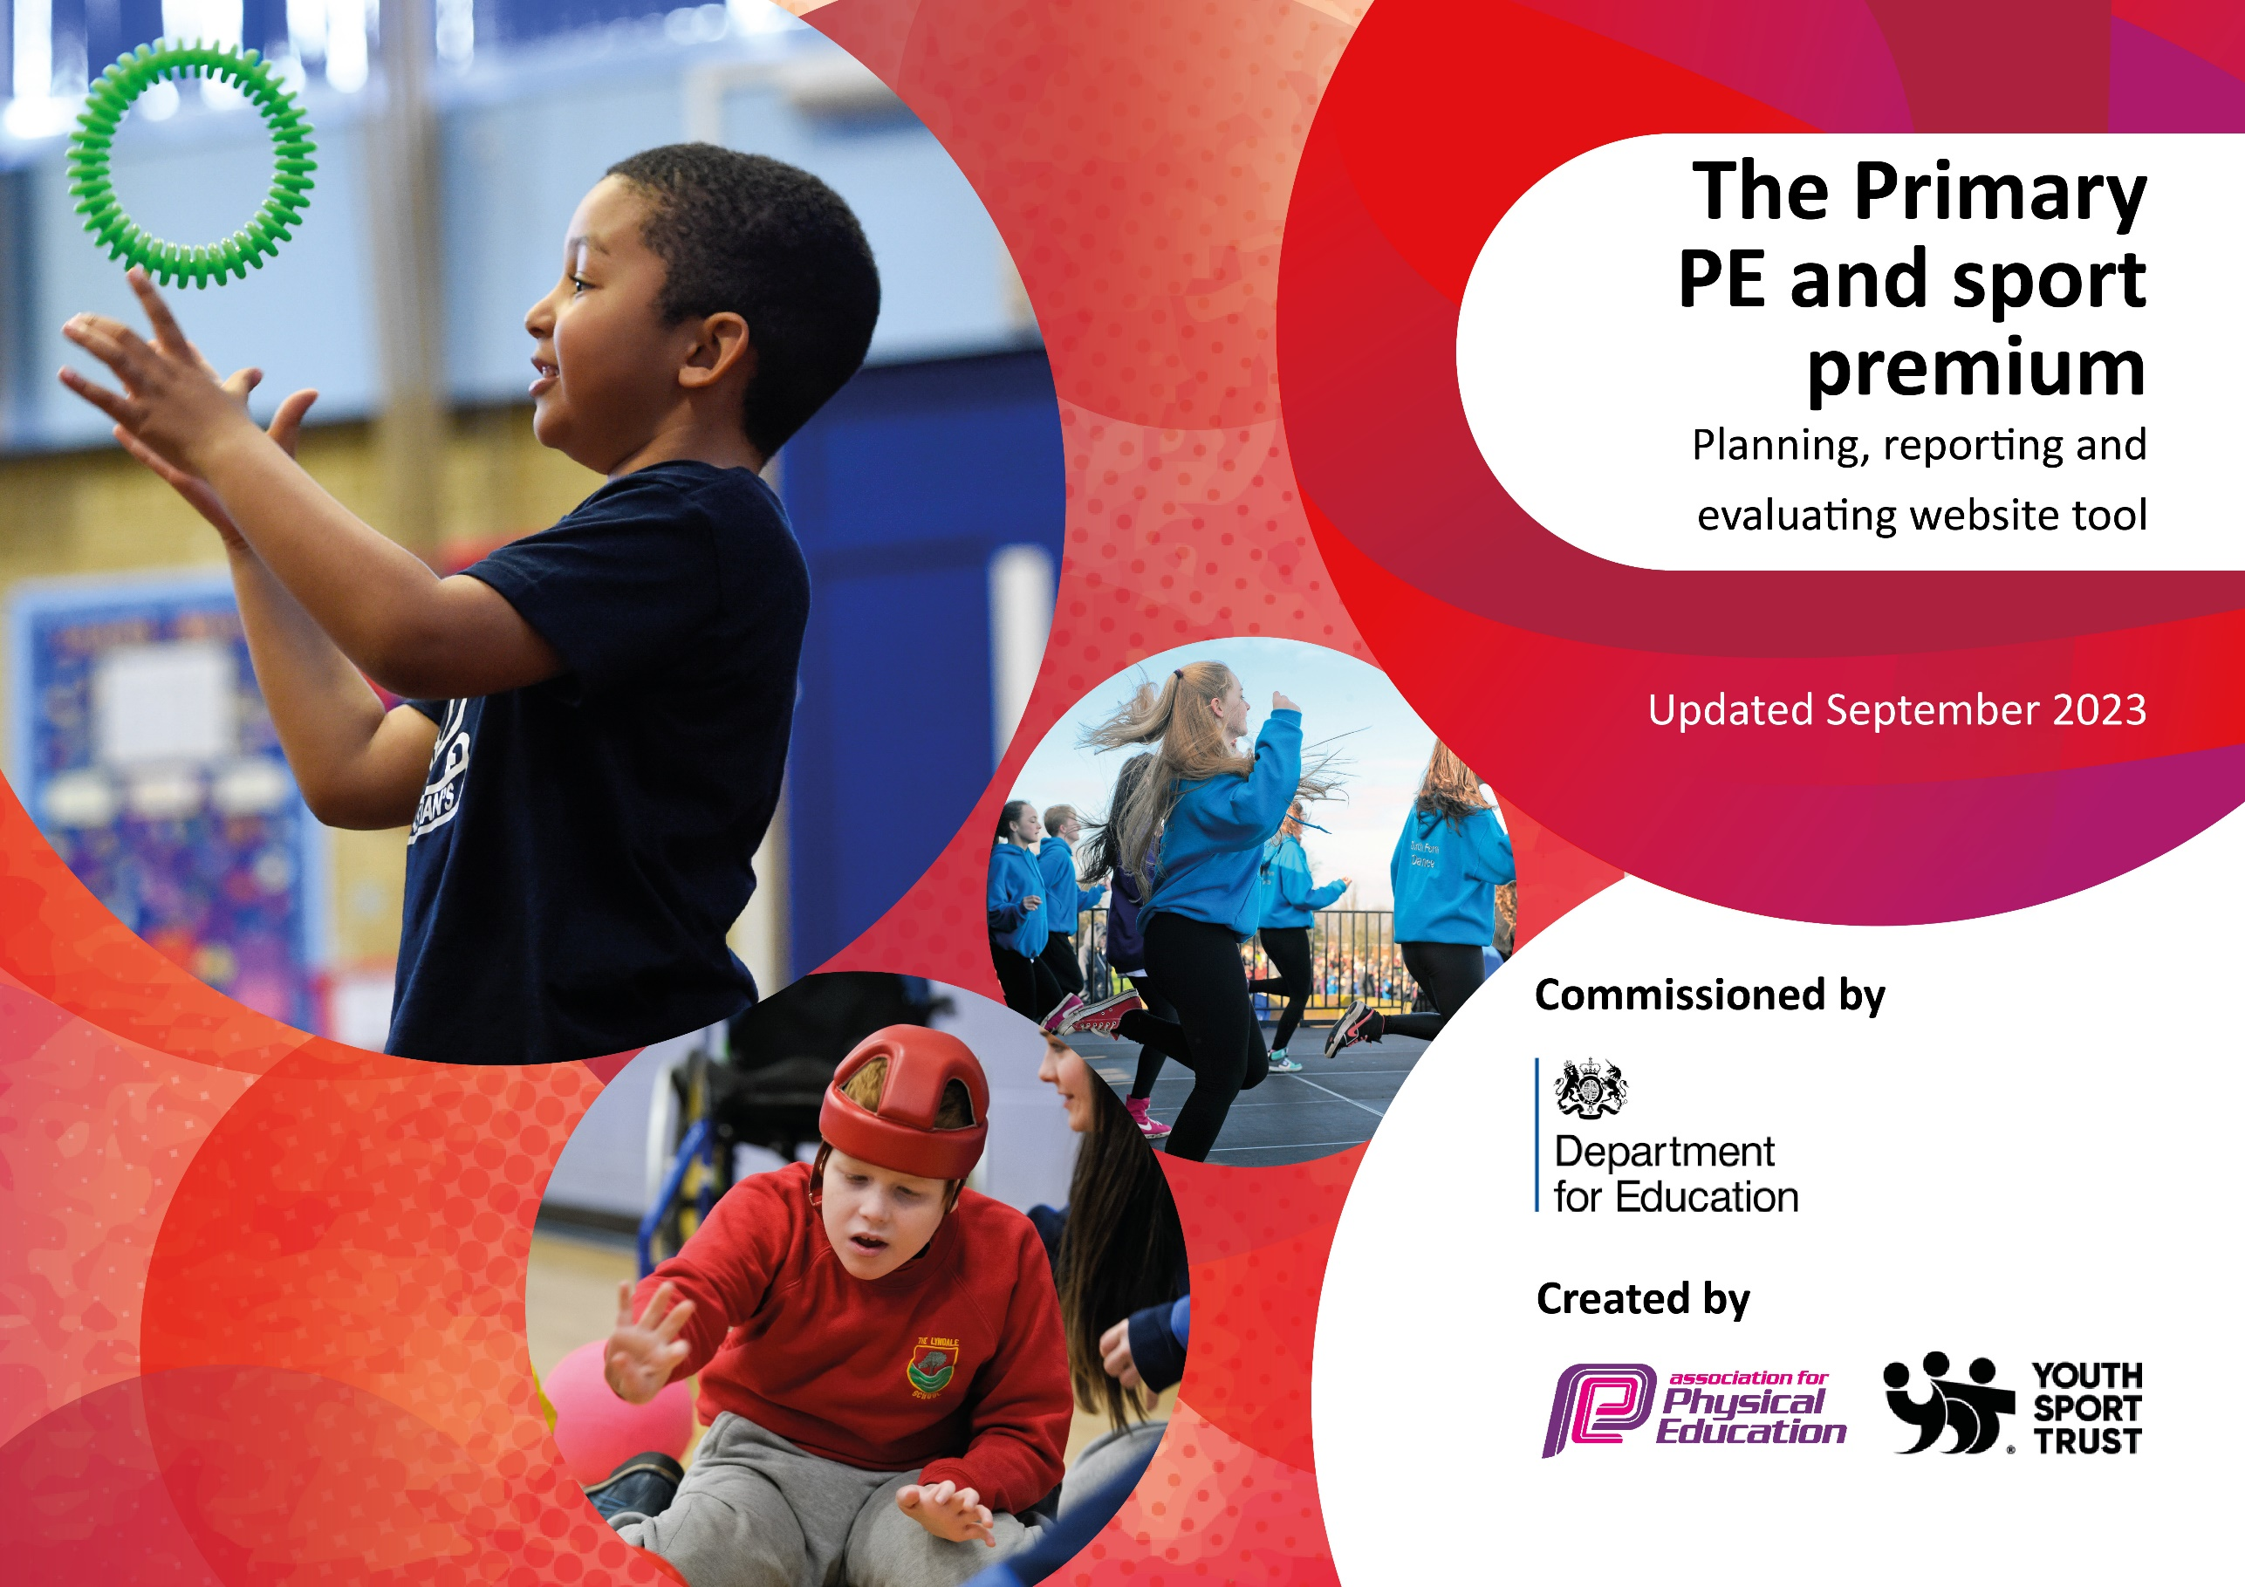

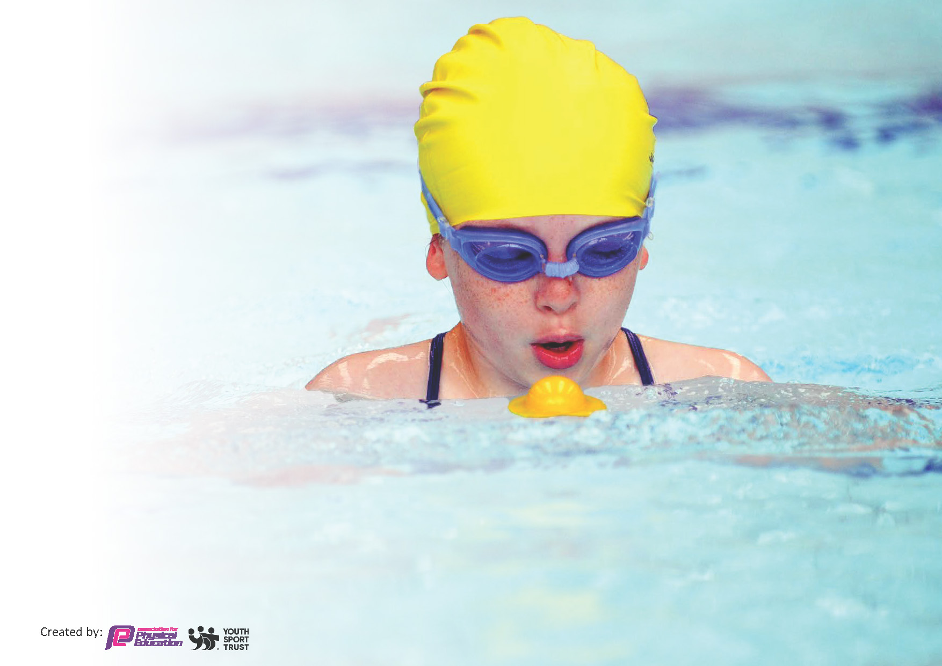
This template can be used for multiple purposes:
by:
- It enables schools to effectively plan their use of the Primary PE and sport premium
- It helps schools to meet the requirements (as set out in guidance) to publish information on their Primary PE and sport premium
- It will be an effective document to support Ofsted inspections enabling schools to evidence progress in Physical Education (PE) and evidence swimming attainment, which forms part of the PE National Curriculum. We would recommend schools consider
the Intent, Implementation and Impact of any spend, as examined within the Education Inspection Framework.

It is important that your grant is used effectively and based on school need.

Schools must use the funding to make additional and sustainable
improvements to the quality of the PE, School Sport and Physical Activity (PESSPA)
they offer. This means that you should use the Primary PE and sport premium to:

- Build capacity and capability within the school to ensure that improvements made now will benefit pupils joining the school in future years
- Develop or add to the PESSPA activities that your school already offers.

The Primary PE and sport premium should not be used to fund capital spend projects; the school’s core budget should fund these. Further detail on capital expenditure can be found in the updated Primary PE and sport premium guidance.

The Primary PE and sport premium guidance, outlines 5 key priorities that funding should be used towards. It is not

necessary that spending has to meet all the key priorities, you should select the priorities that you aim to use any funding towards.

Although completing this template is not a requirement for schools, schools are required to publish details of how they spend this funding. Schools must also outline what the impact this funding has had on pupils’ PE and sport participation and attainment and how any spending will be sustainable in the future. All funding must be spent by 31st July 2024.

The Department for Education has worked closely with the Association for Physical Education (afPE) and the Youth Sport Trust (YST) to develop this template and encourages schools to use it. This template is an effective way of meeting the reporting requirements of the Primary PE and sport premium.
Review of last year’s spend and key achievements (2022/2023)

We recommend you start by reflecting on the impact of current provision and reviewing your previous spend.

Activity/Action | Impact | Comments
Improving resources for PE lessons  CPD  Extra lunchtime staff to provide cycling and running opportunities.  LLC festivals and competitions  Competition entry costs  Coach travel to events  Lunchtime physical activity equipment  Extra swimming | Increasing engagement in PE particularly amongst SEN children.  Greater staff knowledge of PE and increasing quality of teaching PE.  Increase in number of children cycling to school and % of children able to ride bikes.  Increasing participation in sport particularly amongst girls  Greater number of children entering competitive sport  Graeter engagement in physical activity during lunchtimes/playtimes  Greater % of children able to swim 25m

Key priorities and Planning
This planning template will allow schools to accurately plan their spending.

Action – what are you planning to do | Who does this action impact? | Key indicator to meet | Impacts and how sustainability will be achieved? | Cost linked to the action
Continue to develop lunchtime sport sessions/activities for pupils.  Continue to offer competitive sport and increase the amount of children accessing this offer particularly girls.  Develop the daily run further to include family sessions for parents to run with their children.  Increasing the opportunities for physical activity in the EYFS area through multi surface and physical equipment | Lunchtime supervisors / teaching staff, coaches - as they need to lead the activity  pupils – as they will take part.  PE Lead/ Headteacher to work on calendar of events and increasing children who access the events.  PE lead to develop opportunities for parent/families  EYFS & KS1 children able to engage in physical activity during range of weather. | Key indicator 2 -The engagement of all pupils in regular physical activity – the Chief Medical Officer guidelines recommend that all children and young people aged 5 to 18 engage in at least 60 minutes of physical activity per day, of which 30 minutes should be in school.  Key indicator 4: Broader experience of a range of sports and activities offered to all pupils.  Key indicator 5: Increased participation in competitive sport.  Key indicator 2 -The engagement of all pupils in regular physical activity  Key indicator 3 - The profile of PE and sport is raised across the school as a tool for whole school improvement.  Key indicator 2 -The engagement of all pupils in regular physical activity | More pupils meeting their daily physical activity goal, more pupils encouraged to take part in PE and Sport Activities.  More children engaged in competitive sport.  More children and families completing daily exercise and encouraging further activity at home.  Increased amounts of children accessing physical activity during the day | £4000 costs for additional staff to support lunchtime sessions and extra equipment.  £3000 for coach travel (disadvantaged)  £2000 Entry Fees  £2000 to develop time and opportunity/ supervising.  £5,170

CPD for teachers. | Primary generalist teachers and specialist training for PE lead | Key Indicator 1: Increased confidence, knowledge, and skills of all staff in teaching PE and sport.  Key indicator 5: Increased participation in competitive sport. | Primary teachers more confident to deliver effective PE supporting pupils to undertake extra activities inside and outside of school, including teaching water safety and swimming and as a result improved % of pupil’s attainment in PE. | £4000 for swimming and general PE CPD.

Key achievements 2023-2024
This template will be completed at the end of the academic year and will showcase the key achievements schools have made with their Primary PE and sport premium spending.

Activity/Action | Impact | Comments

Swimming Data – July 2024
Meeting National Curriculum requirements for swimming and water safety.
Priority should always be given to ensuring that pupils can perform safe self-rescue even if they do not fully meet the first two requirements of the National Curriculum programme of study

Question | Stats: | Further context  Relative to local challenges
What percentage of your current Year 6 cohort can swim competently, confidently and proficiently over a distance of at least 25 metres? | %
What percentage of your current Year 6 cohort can use a range of strokes effectively [for example, front crawl, backstroke, and breaststroke]? | %

What percentage of your current Year 6 cohort are able to perform safe self-rescue in different water-based situations? | %
If your schools swimming data is below national expectation, you can choose to use the Primary PE and sport premium to provide additional top-up sessions for those pupils that did not meet National Curriculum  requirements after the completion of core lessons. Have you done this? | Yes/No
Have you provided CPD to improve the knowledge and confidence of staff to be able to teach swimming and water safety? | Yes/No

Signed off by:

Head Teacher: | Mr T Parkin
Subject Leader or the individual responsible for the Primary PE and sport premium: | Mr T Parkin – Headteacher  Mrs Holland – PE Lead
Date: | July 2023

