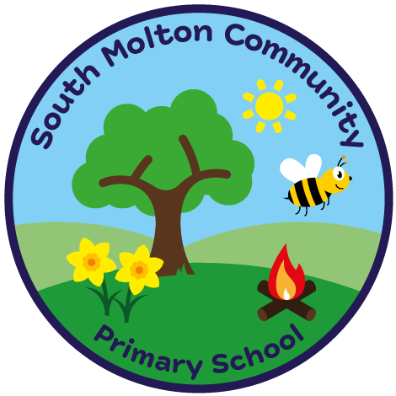
South Molton Community Primary School
Ofsted Number: 113168

BREAKFAST CLUB BOOKING FORM – FIRST HALF Summer term 2024

£3.00 per session 8.00am – 8.45am
Includes a healthy breakfast

Child/Children Name ………………………..………………..…..…….Class/Classes…………………….....

W / C | Monday | Tuesday | Wednesday | Thursday | Friday
15/04/2024
22/04/2024
29/04/2024
6/05/2024 | XXXXXXXXXXXX
13/05/2024
20/05/2024

Signed _______________________________

Completed booking forms and payment MUST be in advance, via ParentPay
Breakfast club fees are non-refundable.
Please drop off your child at the Hall.

South Molton Community Primary School
Ofsted Number: 113168

BREAKFAST CLUB BOOKING FORM – FIRST HALF Summer Term 2024

£3.00 per session 8.00am – 8.45am
Includes a healthy breakfast

Child/Children Name ………………………..………………..…..…….Class/Classes…………………….....

W / C | Monday | Tuesday | Wednesday | Thursday | Friday
15/04/2024
22/04/2024
29/04/2024
06/05/2024 | XXXXXXXXXXXX
13/05/2024
20/05/2024

Signed _______________________________

Completed booking forms and payment MUST be in advance, via ParentPay
Breakfast club fees are non-refundable.
Please drop off your child at the Hall.

