DISHES AND THEIR ALLERGEN CONTENT – Harbour Partnership Trust – Primary School – April to October 26 Menu
✓ Contains ✓ May Contain
 | 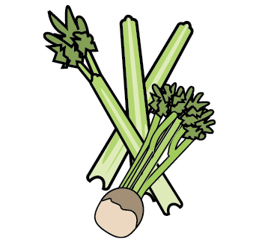 | 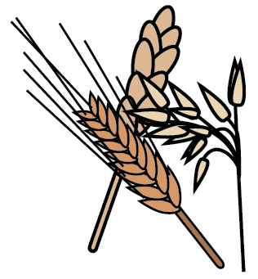 | 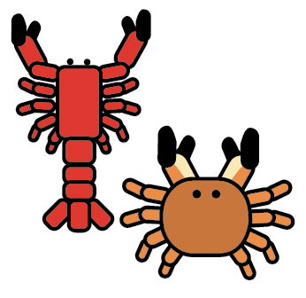 | 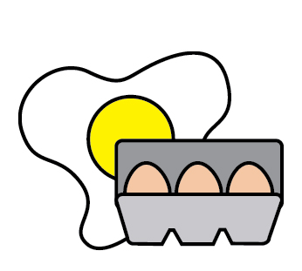 | 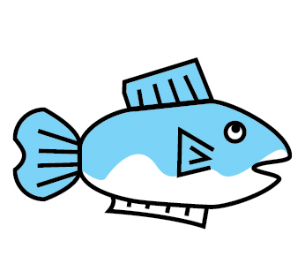 | 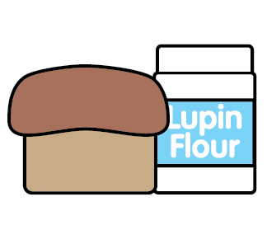 | 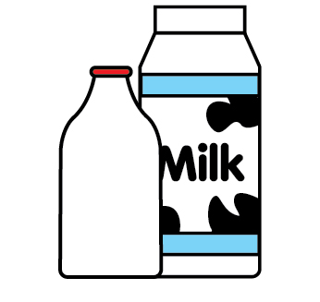 | 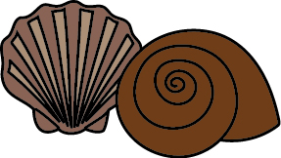 | 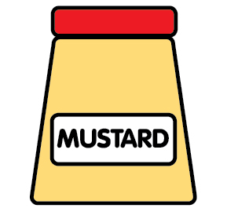 | 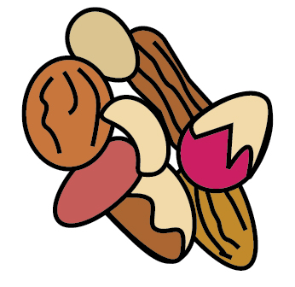 | 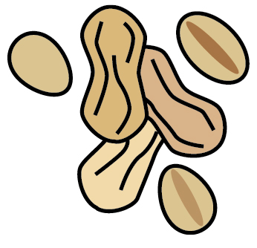 | 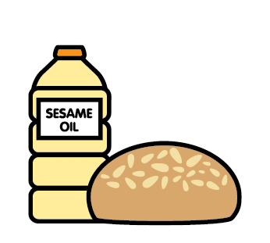 |  | 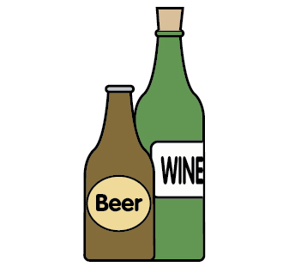
 | Celery | Cereals containing gluten | Crustaceans | Eggs | Fish | Lupin | Milk | Mollusks | Mustard | Nuts | Peanuts | Sesame seeds | Soya | Sulphites
WEEK 1
Monday
Pizza (Mix) |  | ✓ |  | ✓ |  |  | ✓ |  |  |  |  |  | ✓
Pizza (Base) |  | ✓
Whol. Pizza Base |  | ✓ |  | ✓ |  |  | ✓
Sauce & Mozzarella & Ched. Cheese |  |  |  |  |  |  | ✓
Pasta |  | ✓
Veggie Sausage
Egg Mayo Sandwich |  | ✓ |  | ✓ |  |  |  |  |  |  |  |  | ✓
Waffles |  | ✓ |  | ✓ |  |  | ✓ |  |  |  |  |  | ✓
Summer Berries & Syrup
Jacket Potato with Beans
Jacket Potato with Cheese |  |  |  |  |  |  | ✓
Jacket Potato with Tuna Mayo |  |  |  | ✓ | ✓
Tuesday
Beef Lasagne |  | ✓ |  | ✓ |  |  | ✓ |  | ✓ |  |  |  | ✓
Garlic Bread |  | ✓ |  |  |  |  | ✓
Curried Noodles |  | ✓ |  | ✓
Quorn Pieces |  |  |  |  |  |  |  |  | ✓
Cheese & Tom Sandwich |  | ✓ |  |  |  |  | ✓ |  |  |  |  |  | ✓
Pip Lolly
Wednesday
Roast Chicken
Stuffing |  | ✓
Cauliflower Bites
Tuna Mayo Wrap |  | ✓ |  | ✓ | ✓
Potatoes |  |  |  |  |  |  |  |  |  |  |  |  |  | ✓
Gravy
Ice Cream Pots |  |  |  |  |  |  | ✓
Thursday
Jumbo Fish Finger |  | ✓ |  |  | ✓
Feta & Potato Puff Tart |  | ✓ |  |  |  |  | ✓ |  | ✓
Pork Sausage Roll |  | ✓ |  |  |  |  | ✓
Potato Wedges
Lemon Drizzle Cake |  | ✓ |  | ✓ |  |  | ✓ |  |  |  |  |  | ✓
Friday
Quorn Burger  Code 311198 |  | ✓ |  | ✓ |  |  | ✓
Cheese |  |  |  |  |  |  | ✓
Floured Bun |  | ✓ |  |  |  |  |  |  |  |  |  | ✓
Veggie Nuggets |  | ✓
Ham Sandwich |  | ✓ |  |  |  |  |  |  |  |  |  |  | ✓
Tom. Ketchup |  |  |  |  |  |  |  |  |  |  |  |  |  | ✓
Pasta |  | ✓
Fries
Fruity Shortbread |  | ✓ |  |  |  |  |  |  |  |  |  |  | ✓
WEEK 2
Monday
Cheese & Tomato Pasta |  | ✓ |  |  |  |  | ✓
Quorn Bolognaise |  | ✓ |  | ✓
Pasta |  | ✓
Crusty Bread |  | ✓ |  |  |  |  |  |  |  |  |  | ✓
Egg Mayo Sandwich |  | ✓ |  | ✓ |  |  |  |  |  |  |  |  | ✓
Fruit Iced Smoothie
Tuesday
Chicken Sauce |  |  |  |  |  |  | ✓ |  | ✓
Tagliatelle |  | ✓ |  | ✓ |  |  |  |  | ✓ |  |  |  | ✓
Garlic Bread |  | ✓ |  |  |  |  | ✓
Cheese Pizza Baguette |  | ✓ |  |  |  |  | ✓ |  |  |  |  | ✓
Ham Sandwich |  | ✓ |  |  |  |  |  |  |  |  |  |  | ✓
Fruit Platter
Wednesday
Toad in Hole |  | ✓ |  | ✓ |  |  | ✓
GF Pork Sausage |  |  |  |  |  |  |  |  |  |  |  |  |  | ✓
Veggie Sausage
Y.Pud |  | ✓ |  | ✓ |  |  | ✓
Potatoes |  |  |  |  |  |  |  |  |  |  |  |  |  | ✓
Tuna Mayo Bap |  | ✓ |  | ✓ | ✓ |  |  |  |  |  |  | ✓
Pineapple Cake |  | ✓ |  | ✓ |  |  |  |  |  |  |  |  | ✓
Thursday
Butcher Pork Meatballs in Tom. Sauce |  | ✓ |  |  |  |  |  |  |  |  |  |  |  | ✓
Finger Roll |  | ✓ |  |  |  |  |  |  |  |  |  | ✓
Cheese Wheel |  | ✓ |  |  |  |  | ✓ |  | ✓
Sausage Roll |  | ✓ |  |  |  |  | ✓
Chocolate & Date Cookie |  | ✓ |  | ✓ |  |  |  |  |  |  |  |  | ✓
Ginger Biscuits |  | ✓ |  |  |  |  |  |  |  |  |  |  | ✓
Anzac Biscuit |  | ✓ |  |  |  |  | ✓ |  |  |  |  |  | ✓ | ✓
Lemon Biscuit |  | ✓ |  | ✓ |  |  |  |  |  |  |  |  | ✓
Oat & Date Cookie |  | ✓ |  |  |  |  |  |  |  |  |  |  | ✓
Friday
Mini Cheese Pasty  Code 383162 |  | ✓
Veggie Nuggets |  | ✓
Cheese Sandwich |  | ✓ |  |  |  |  | ✓ |  |  |  |  |  | ✓
Fries
Pasta |  | ✓
Tom. Ketchup |  |  |  |  |  |  |  |  |  |  |  |  |  | ✓
Chocolate & Date Krispie Cake |  | ✓
WEEK 3
Monday
Macaroni Cheese |  | ✓ |  |  |  |  | ✓ |  | ✓
Garlic Bread |  | ✓ |  |  |  |  | ✓
Sweet Chill Halloumi Wrap |  | ✓ |  | ✓ |  |  | ✓
Egg Mayo Sandwich |  | ✓ |  | ✓ |  |  |  |  |  |  |  |  | ✓
Fruit Crunch Pot |  | ✓ |  |  |  |  | ✓
Tuesday
Chicken & Butternut Curry
Rice
Quorn Stir Fry |  |  |  |  |  |  |  |  | ✓ |  |  |  | ✓
Noodles |  | ✓ |  | ✓
Pizza Muffin |  | ✓ |  |  |  |  | ✓ |  |  |  |  |  | ✓
ABC Cake |  | ✓ |  | ✓ |  |  |  |  |  |  |  |  | ✓
Wednesday
Roast Gammon
Pineapple
Vegetable Wellington |  | ✓ |  | ✓ |  |  | ✓
Potatoes |  |  |  |  |  |  |  |  |  |  |  |  |  | ✓
Cheese & Tomato Sandwich |  | ✓ |  |  |  |  | ✓ |  |  |  |  |  | ✓
Ice Cream Pots |  |  |  |  |  |  | ✓
Thursday
Salmon & Broccoli Bake |  | ✓ |  |  | ✓ |  | ✓
Vegan Sausage Roll |  | ✓ |  | ✓ |  |  | ✓ |  |  |  |  |  |  | ✓
Ham Sandwich |  | ✓ |  |  |  |  |  |  |  |  |  |  | ✓
Cookie
See
Previous
Friday
Quorn Burger |  | ✓ |  | ✓ |  |  | ✓
Cheese |  |  |  |  |  |  | ✓
Bun |  | ✓
Veggie Nuggets |  | ✓ |  |  |  |  |  |  |  |  |  | ✓
Tuna Mayo Wrap |  | ✓ |  | ✓ | ✓
Fries
Tom. Ketchup |  |  |  |  |  |  |  |  |  |  |  |  |  | ✓
Vegan Brownie |  | ✓ |  |  |  |  |  |  |  |  |  |  | ✓
Wholemeal Bread |  | ✓ |  |  |  |  |  |  |  |  |  |  | ✓
Malted Baguette |  | ✓ |  |  |  |  |  |  |  |  |  | ✓
Yoghurt |  |  |  |  |  |  | ✓
Alternative Allergen Products
Vanilla Ice Cream
Pasta
Sausages |  |  |  |  |  |  |  |  |  |  |  |  |  | ✓
Sausages
On request
Bread Buns
Alpro Yoghurts |  |  |  |  |  |  |  |  |  |  |  |  | ✓
Quorn Pieces |  |  |  |  |  |  |  |  | ✓
Vegan Pancakes |  | ✓ |  | ✓ |  |  | ✓
Pip Lolly
Veg. Burger
Fish Finger |  |  |  |  | ✓
Vegan Meatballs

