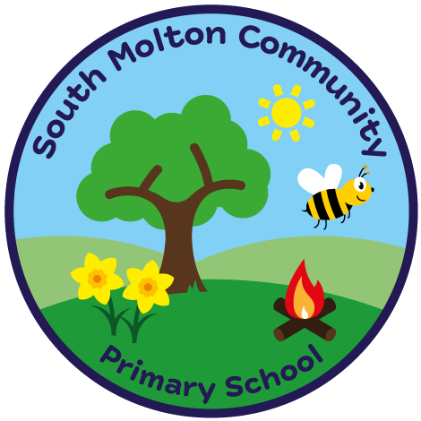
South Molton Community Primary School
Ofsted Number: 113168

BREAKFAST CLUB BOOKING FORM – SECOND HALF Spring term 2024

£3.00 per session 8.00am – 8.45am
Includes a healthy breakfast

Child/Children Name ………………………..………………..…..…….Class/Classes…………………….....

W / C | Monday | Tuesday | Wednesday | Thursday | Friday
19/02/2024
26/02/2024
04/03/2024
11/03/2024
18/03/2024
25/03/2024 |  |  |  |  | XXXXXXXXXXXX

Signed _______________________________

Completed booking forms and payment MUST be in advance, via ParentPay
Breakfast club fees are non-refundable.
Please drop off your child at the Hall.

South Molton Community Primary School
Ofsted Number: 113168

BREAKFAST CLUB BOOKING FORM – SECOND HALF Spring Term 2024

£3.00 per session 8.00am – 8.45am
Includes a healthy breakfast

Child/Children Name ………………………..………………..…..…….Class/Classes…………………….....

W / C | Monday | Tuesday | Wednesday | Thursday | Friday
19/02/2024
26/02/2024
04/03/2024
11/03/2024
18/03/2024
25/03/2024 |  |  |  |  | XXXXXXXXXXXX

Signed _______________________________

Completed booking forms and payment MUST be in advance, via ParentPay
Breakfast club fees are non-refundable.
Please drop off your child at the Hall.

